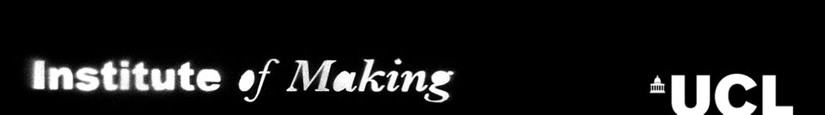

The Prof. Heinz Wolf Materials Bursary

Application Form

All student members of the Institute of Making are eligible to apply for a Materials Bursary of up to £250 to go towards the material costs of any project undertaken within the Institute of Making.

Any member awarded the bursary will be required to document the process of materials experimentation, play and/or making that the bursary pays for. This should include photographs and a brief reflective report, or text that may be used on the Institute of Making blog or annual report to celebrate the outcomes of the bursary.

In order to apply for a Materials Bursary, please complete the following form. The deadline for this round of applications is 5pm on Thursday 24th Oct. All applications will be considered, though we cannot guarantee all will be funded. The Institute of Making will hold a second call for applications in term two. Members are only eligible for one bursary each academic year.

Applications will be judged by the Bursary Committee, who will be looking for elements of innovation, exploration, commitment and focus in the projects proposed. Applications should be submitted to members@instituteofmaking.org.uk

Member Name:
UPI number:
UCL Department:
UCL email address:
Have you completed your level 1 Institute of Making induction (ie, does your UCL card work on our door)? Y N

Project Title:

Project Overview/Outline:
(Around 150 words detailing what you want to do)

Budget:
(A detailed breakdown of your costs and then the total amount required to cover them, in other words, how much money do you require and what are you planning to spend it on.)

Declarations:
☐ I understand that if awarded a Materials Bursary, I am required to document what I make and report back to the Institute of Making.
☐ I agree to spend all of the money awarded to me, only on the project I have outlined above.

