Member Challenge:
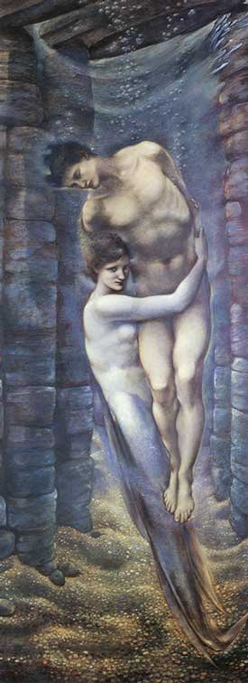
Design and Build a Scrambling Message Machine
1. Info and Application Form
The challenge: Design an interactive messaging machine
Submission deadline: 26th February 2016
Making deadline for winning idea: 1st July 2016
Eligibility: Any inducted member/ member team of the Institute of Making
Prize: £600
To commemorate the successful laying of the Atlantic Cable in 1866, The AHRC-funded project, Scrambled Messages: The Telegraphic Imaginary 1857-1900 is planning an art-and-science exhibition at the Guildhall Art Gallery in London which will run September 2016- early February 2017.
The exhibition title is Victorians Decoded: Art and Telegraphy
We are inviting imaginative preliminary designs for an interactive messaging machine, to be displayed at the exhibition.
The exhibition will be free and open to a broad public. Our aim is to display the connections between ideas relating to the history of telegraphy and the art and literary culture of the Victorian period for visitors, including school students, tourists from the UK and abroad, technophiles and consumers of culture spanning a wide age range. The website for the project is http://www.scrambledmessages.ac.uk/
The machine should be visually effective, arresting, surprising, amusing, and create an engaging encounter with the visitor. It should hold its own amongst the display of large-scale Victorian painting.
Any questions and for more info contact members@instituteofmaking.org.uk
2. The Prize
- receive a cash prize of £600 upon completion of machine
- be named in press releases about the exhibition
- be invited to present the machine at the Grand Opening Party and/or Press Preview or the exhibition
- receive a free ticket to the international academic conference which accompanies the exhibition, and the opportunity to present your work for the machine at that conference
All entries will be published on our website unless otherwise directed.

3. The Design Brief:
- Competition entries should interpret ‘telegraphy’ freely and use the machine to make something interesting happen (see Section 4 below for possible inspiration).
- Your machine will be a valuable apparatus with which to challenge lazy assumptions and bring the science and technology of electronic messaging into sharp focus for the exhibition visitors.
- The machine should not be larger than a standing person. (6’ x 3’ x3’).
- Estimates of cost of construction must be included (we will only cover cost up to £1,000).
- The machine must be robust and capable of running continuously over a period of 5 months with minimal maintenance or supervision and must be built by 1st July 2016.
- The machine must be made at the Institute of Making, technical assistance will be provided.
- The ensuring of public safety is an important criterion, as is the avoidance of visitor-generated offensive text (use of code could remove any risk).
4. Possible approaches/inspiration.
- The machine could reference early telegraph technologies (for instance in Steampunk mode) and reference contemporary electronic communications technologies.
- Sections of the exhibition will be addressing the themes of Distance, Transmission, Coding and Impedance: the machine could speak to one or all of these.
- The chance for visitors to take away a coded message on a paper strip.
- The chance for visitors to text message from their own phones and for this electronic message to be ‘materialised’ in some form.
- The use of music or sound – Charles Wheatstone, one of the inventors of the telegraph, was also the inventor of the Wheatstone Concertina and the Symphonium (examples of which will be on display in the exhibition)
- The use of literary texts – particularly marine or Atlantic ones of the period – such as Melville’s Moby Dick, for example, as coding texts, or as inspirations for design
- The use of cable materials (gutta percha/copper/jute) to make a tactile connection with the material telegraph technology.
- The use of morse or other code as a design/operational element.
- The dramatisation of the switch from analogue to digital communications.
- The use of an underwater/deep sea theme.

Application Form
Member Name:
UPI (found on the front of your UCL ID card):

UCL department and course/job title:

UCL email address:

Mobile phone number:

Have you completed your level 1 Institute of Making new members induction?:
Your Idea
Title (if any):

Concept (short summary about how it meets the Brief):

Materials used with estimated costs:

How will it be installed in the gallery space – does it have power/dark/other special needs:

Send your completed form to members@instituteofmaking.org.uk by 29 February 2016

