*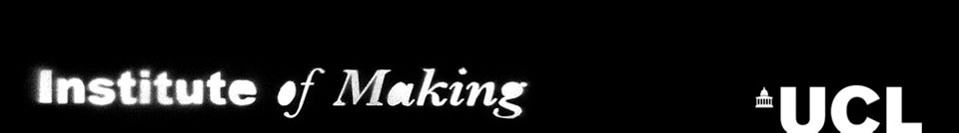*

**Bridging the Gaps  
SUMMER STUDENTSHIP**

Application Form

**Who can apply?**

The awards will be available to current undergraduate students (UK/Home, EU and Overseas) at UCL. The project must involve two supervisors, from two different departments at UCL.

**What is supported?**

Studentships support a maximum of 10 weeks of work. This will be divided into three parts:

1) A subsistence allowance of £200/week.

2) Up to £300 towards related materials costs that derive from the research project.

3) Travel costs will be provided in exceptional circumstances, or where the needs of the project require it.

**How to apply:**

Students and supervisors make a joint, one-page application, using the form below. Please outline the project and give a summary of what the student will gain from the work. The student should also include their curriculum vitae.

Applications should be sent to Sarah Wilkes at the Institute of Making: [research@instituteofmaking.org.uk](mailto:research@instituteofmaking.org.uk).

**Deadline:**

The deadline for applications is the **5pm on the 26th May 2014**. Decisions will be made shortly after the deadline date.

**Selection criteria:**

Projects should have the potential to bridge the gaps between disciplines on the topic of materials and making. Preference will be given to students and researchers that actively engage with the Institute of Making. Preference will be given to projects that initiate a new collaboration between departments at UCL.

If you have any questions regarding your application, please feel free to contact the Institute of Making team.

**Who will make decisions?**

A committee ranks both the applications and the students. All applications will be considered, though we cannot guarantee all will be funded. Projects with the highest ranking will be supported, subject to the availability of funds. Students and supervisors will be notified shortly after the application deadlines.

**After the award:**

All summer studentship projects must be completed by the **28th August 2014**.

Students will be required to document their research experience, providing a couple of images and a one-page summary of their achievements and experience that may be used on the Institute of Making blog ([www.instituteofmaking.org.uk](http://www.instituteofmaking.org.uk)) or annual report to celebrate the outcomes of the studentship.

In order to apply, please complete all the fields below, and submit with the student’s CV. Applications should be submitted to [research@instituteofmaking.org.uk](mailto:members@instituteofmaking.org.uk) by **5pm on Monday 26th May 2014.**

**PLEASE COMPLETE ALL OF THE FOLLOWING FIELDS:**

Student Name:

UPI Number:

UCL Email Address:

First Supervisor:

UCL Department:

Second Supervisor:

UCL Department:

Project Title:

Project Overview/Outline:

(One page description of the research project to be undertaken, the supervision to be given by each department, and the benefit to the student)

Required budget for research-associated materials costs:

(Please provide a detailed budget of any additional materials costs related to this research project – up to the value of £300)

Student declaration:

☐ I understand that if awarded a Summer Studentship, I am required to document my studentship and report back to the Institute of Making.

☐ I agree to use any materials costs awarded to me on *only* the project I have outlined above.

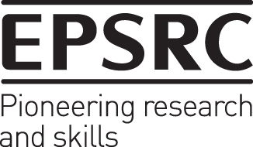 UCL Engineering logo_OrangeLines