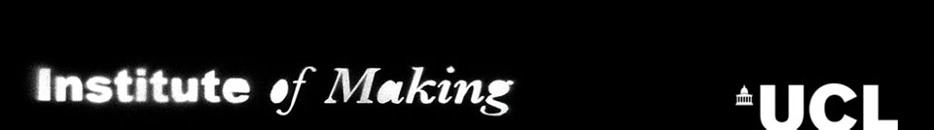

Glass as a material with Shelley James
Monday 23rd March, 2015
Application Form

Dr Shelley James trained in textiles and printmaking before completing a PhD by practice in the Ceramics and Glass Department at the Royal College of Art. Her practice combines traditional approaches with the development of new techniques to explore the creative potential of glass. Shelley has an ongoing residency at the Bristol Eye Hospital and has recently completed the prestigious Jerwood Commission in collaboration with psychologists and crystallographers to explore perception of space and symmetry. She is currently developing a new body of work with the mathematician Sir Roger Penrose on quasi-crystals for exhibition at the Royal Society Summer Exhibition 2015.

In this masterclass you will be invited to attack everyday objects with heat, hammer and acid to test the limits of the vast range of materials that go by the name of glass. You will also be given a brief introduction to the history of glass, its role in science and culture.

Participants will be invited to explore five processes:

1: Thermal shock – Explore the reaction of different types of glass to different forms of heat.
2: Thermal expansion – Participants will be invited to take small sections of glass and stack them together in microwave kilns to see what happens when you pair materials of different expansion coefficients together and heat them to varied temperatures.
3: Thermal flow – Explore how glass moves with heat, observing the role of material composition, shape and thickness on flow.
4: Impact – How does glass break on impact, considering the role of material composition, shape, thickness and force on the propensity to fracture, size and shape of the fragments etc.?
5: Chemical attack – Explore how acid attacks the surface of material considering the role of coatings and composition.

This workshop is free, and all materials will be provided. Applicants need to be inducted members of the Institute of Making.
To apply for a place: please complete the following form, and return to events@instituteofmaking.org.uk
Deadline for applications 1st March
You will be notified whether you’ve got a place by 11th March at the latest.
All applications will be considered, though we cannot guarantee all will get a place. Applications will be looked at by the Institute of Making committee and Shelley James, who will be looking for commitment to a whole day, an interest or passion for glass as a material and a demonstration of how this masterclass will help you further an idea or project.

Member Name:

UPI number:

UCL Department:

UCL email address:

Have you completed your level 1 Institute of Making induction (i.e., does your UCL card work on our door)?

Do you already work with glass? (making or research)

Have you worked with or experimented with glass previously? If so, please state what.

How would attending this masterclass benefit you?

